9. Saves Souls

This is what life on earth is all about and it has its basis in the Letter of James, chapter 5, verse 19: “Brothers, if anyone among you should stray from the truth and someone bring him back, he should know that who ever brings back a sinner from the error of his way will save his soul from death and will cover a multitude of sins.”

Therefore, if you help to bring back a fallen away Catholic, or bring a convert into the Catholic religion – if you are God’s instrument to do that – the Bible says that you will cover a multitude of sins and save your own soul from death as well. The Legion, with its program of works which includes the friendly encouraging of the lapsed to live again their Catholic Faith ensures its members of this future blessing.

10. Masses For Your Soul

At present, throughout the world, there are approximately 600,000 Legion groups and by rule, each group has a Mass said for all deceased Legionaries in the month of November.

So, you as a Legion of Mary member, after your death can be sure of having six hundred thousand Masses celebrated for you. Imagine sitting in Purgatory and along comes November 1st, with six hundred thousand Masses, being said for you. If you are not out of there soon, it’s through no fault of the Legion of Mary!

Come join us at a Legion of Mary meeting at Saint Gregory the Great Church
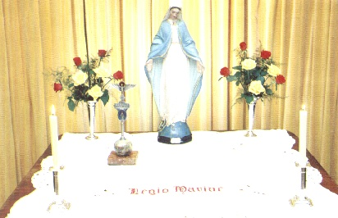
What is it?

The Legion of Mary is the largest apostolic organization of lay people in the Catholic Church, with well over six million active members in almost every country of the world. It has been active in the United States since 1931, has been approved by the last six Popes through Pope John Paul II, and was endorsed by the Second Vatican Council. The main purpose of the Legion of Mary is to give glory to God through the sanctification of its members.

What does it do?

Members become instruments of the Holy Spirit through a balanced program of prayer and service. Works include evangelization, parishioner visitation, prison ministry, visitation of the sick or aged, religious education, visiting the newly baptized, Pilgrim Virgin Statue visits, Sacred Heart enthronements and any other tasks assigned by the pastor. Legionaries are under the guidance of a spiritual director named by the pastor. The Legion is, in essence, an extension of the heart and hands of the Pastor.

Who Can Belong?

The Legion of Mary is open to all Catholics who:

- Faithfully practice their religion
- Are animated by the desire to participate in the Church’s Apostolate through membership in the Legion;

How Do I Start?

The first step is to visit a meeting of the Legion of Mary. You are always welcome and can go on one of the work assignments with an experienced member if you choose. There are currently X Legion of Mary groups in the parish. They meet in the X Room

- Every X at X
- Every X at X

How Can I get More Information?

For more information, ask any member of the Legion of Mary, or contact an officer of the two groups:

NAME PHONE

NAME PHONE

or visit the website at

www.legionofmarytidewater.com

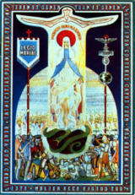

Ten Benefits
Of
Legion of Mary
Membership

The Legion of Mary began in Dublin, Ireland on September 7, 1921. It is now the largest lay apostolic organization in the Catholic Church, with well over six million active Legionaries throughout the world.

Types of work
- Going door-to-door to invite lapsed Catholics and others to return to the sacraments
- Visiting hospitals, nursing homes and prisons
- Visiting families in the parish to foster Catholic devotions
- Other tasks assigned by the pastor

www.legionofmarytidewater.com
1. It Can Help Grow Hair
A true story concerns the late Father Francis Ripley of Liverpool, England.

He wanted to start the Legion in the hospital and was recruiting members. One German patient had been in an explosion in a tank and had lost all his hair and it never grew back. Fr. Ripley asked him to join the Legion .

The solider asked Father whether the Blessed Mother would help his hair grow back if he joined and Fr. Ripley said that he would not be surprised if it did. Three months later the German Legionary had the most beautiful head of blond hair!

The principle is that Our Lord and Our Lady are never outdone in generosity. If we sacrifice some time, effort or energy doing their work, they always give something in return.
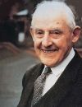
2. School For Saints
Frank Duff, the founder of the Legion of Mary, said that “the Legion makes saints and makes them by the bushel.” It is amazing that an only being 85 years old, it has five lay members whose cause for canonization has been introduced.

If we want to become good at something, we must practice it every week, such as a sport, a hobby, a musical instrument. If we want to “get good” at holiness, we must practice it every week. The Legion gives us that opportunity; it provides an ideal expression of the Catholic vocation. It is a unique privilege and great blessing to be counted in its membership.
3. Fulfills Canon Law
Canon Law 225, the rulebook of the Catholic Church, obliges us to be apostolic: “Since all lay people are assigned to the apostolate by baptism and confirmation, they are bound by the general obligation and they have the right, whether as individuals or organizations or in associations, to strive so that the divine message of salvation may be known and accepted by all people throughout the world.”

Legion of Mary membership makes it easy to follow the rules and be a good Catholic, but it does more: the Legion offers a proven method and motivation for sanctity, thus fulfilling Canon 210 which states: “All Christian faithful must make an effort, in accord with their own condition, to live a holy life and to promote the growth of the Church and its sanctification.”
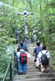
4. Keeps Its Members Young
This can’t be found in Canon Law but it can be shown. For example, Fr. Aedan McGrath, official Legion visitor to the Far East, was still active at 92 years old, and looked to be 75.

Frank Duff, founder of the Legion, was still riding his bicycle at age 91. (In fact, he never drove a car after his first ride, when the engine exploded!) The Legion kept him young in spirit and in body.

There are some little old ladies in Philadelphia who, in their nineties, are still doing their Legion work of going door to door. The Legion continues to keep them young.
5. Teaches the Catholic Faith
During the weekly Legion meeting spiritual formation is found in the rosary, in the Legion prayers, in the spiritual reading and discussion, and in the talk by the spiritual director. Additional help comes from the wisdom and apostolic techniques learned from the reports which are presented and discussed.

Every time legionaries come together to meet it is as if they are gathered at the cenacle with Our Lady, as in the days of the first apostles. Every Legion meeting becomes the Upper Room where modern-day apostles gather together in a cenacle of prayer with Mary, asking the Holy Spirit to come upon them so that they can do great things for the glory of God and the salvation of souls.

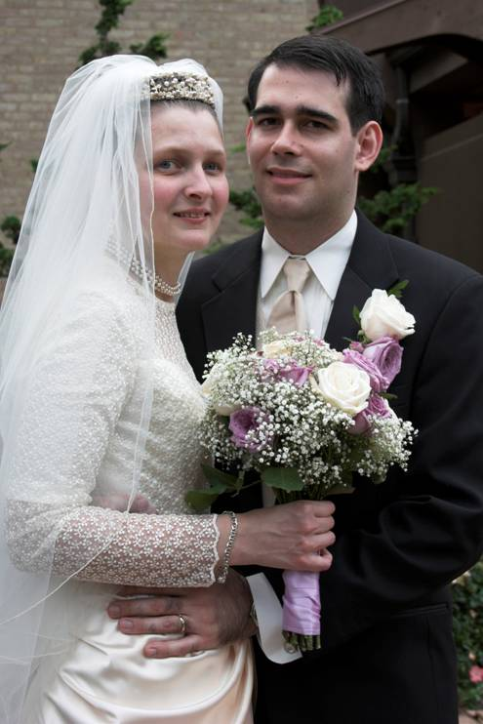

6. Friendships
The Legion’s main purpose is the holiness of the members. It improves our “vertical” relationship we have with God and the Blessed Mother, but it also enriches the “horizontal” relationship of friends we gain as we live the Legion way of life.

The Legion can help develop wonderful life-long friendships with like minded Catholics. It is also a great place to meet a future spouse. One Legion Praesidium in Arlington, VA reported six marriages from one Legion group alone.

7. A Means of Tithing
In Scripture, tithing generally refers to the gift of ten percent of our finances to God. This principle should be applied to our time and effort too. The Legion provides a jump-start on this by requiring that about four hours be set aside each week, which is two percent of our time. Scripture says that when you tithe, God’s blessing to you will be greater than your generosity to Him.

Therefore, as we give time to our Lord and His Mother, they bless us in many ways and we find even more time and blessings in life. The aim is to spend time serving God through a living example and active apostolate.
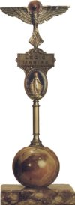
8. Helps Face Judgment Day
What a great blessing it would be to hear Jesus say to us “Come, inherit the Kingdom prepared for you from the foundation of the world, for when I was sick in the nursing home, you Legionaries visited Me. When I was in prison, you came to see Me. When I was hungry for the Truth, you brought Me back to the Church. When I was thirsty for love, you came and comforted Me.”

The spiritual works of mercy – the Legion’s primary program of works, such as encouraging people to come back to the sacraments, helping to get children baptized, making the Catholic Church known to others – will be even more important than the corporal works of mercy (feeding the hungry, clothing the naked) because the soul, unlike the body, is eternal and will last forever in either heaven or hell.

